(本頁中文版如下一頁)
National Chengchi University, 112-2Academic Year
Midterm Exam of Statistics (II), Bonus Test, R Programming

Department/Grade:______________ ID:_______________ Name:_____________
Subject: Statistics (II)
Date: 2024/04/18
This test consists of 5 major questions. (20% each, total score: 100%)
Time period: 15:00~16:00 (total 60 minutes)
_____________________________________________________________________
Notes:
- Download the R exam sheet (112-2-Stat-R-Midterm.zip) from the course website and unzip in your laptop. The zip file contain the question sheet, the answer sheet, and the datasets.
- Answers for this exam should be provided using the R programming language (either Rgui or RStudio). Other programming languages are not permitted.
- During the exam, you may refer to textbooks, lecture notes (including videos, Please bring your own headphones), or browse the internet. However, the use of communication software/APP such as Messenger, IG, Line, etc., is strictly prohibited.
- Any form of cheating or suspicious behavior is not allowed.
- On this answer sheet, please ensure you copy the "executed code and its results (including graphics)" from the R Console and paste it here (in Courier New font, size 10, black text on a white background). This should include both the code and the output, not just one or the other. Finally, the answers for each sub-question should be highlight by yellow color (not just printing the report; the TA shouldn't have to search for the answers)
- Please label your answers in sequence, e.g., (1)a, (1)b, (2)a, etc.
- After completing your answers, save this Word document with the filename "StudentID-FamilyName-Midterm.docx" (replace with your actual "Student ID and FamilyName") and upload it to http://ftp.hmwu.idv.tw:8080/login.html?lang=tchinese .
- Username: stat112, Password: (classroom number) 26xxxx, Folder: "20240418-MidtermExam".
- If the upload site displays a "blank page", move your cursor to the "address bar" and press "Enter". If that doesn't work, try using a different browser (IE/Edge/Firefox/Chrome).
- Uploaded files cannot be deleted. If you need to upload a revised file, please add "-2" to the main filename, e.g., " StudentID-FamilyName-Midterm-2.docx ".

_________________________Wishing you a successful exam______________________________

(English version on the previous page)
國立政治大學112學年度第二學期
統計學(二) 期中R程式加分考

系級:______________ 學號:_______________ 姓名:_____________
考試科目: 統計學(二)
考試日期:2024/04/18
本試題共5大題 (各20%)
考試時間:15:00~16:00 (共60分鐘)
_____________________________________________________________________
注意事項:
- 從教學網站下載電子考卷 (112-2-Stat-R-Midterm.zip)，並於自己的筆電解壓縮。 壓縮檔包含題目卷、答案卷和資料集。
- 本次考題以R程式(Rgui或RStudio)方式作答，其他程式不允許。
- 考試過程中可查詢書本、教學講義或上網(含上課影片，請自備耳機)，禁止利用messenger, IG, Line等等通訊軟體。
- 禁止疑似作弊行為。
- 本答案卷上請務必於R Console內複制「執行後的程式碼及結果(含圖形)」，於本答案卷貼上(Courier New, 10點字，白底黑字)，不是只有程式碼，不是只有報表。最後，將每小題之答案以黃色底高亮起來(不能只印出報表，要助教去找答案)。
- 請依序註明題號: (1)a, (1)b, (2)a 等等。
- 作答完請將此word檔存檔，檔名為「StudentID-FamilyName-Midterm.docx」(更改成自己「學號」、「 姓」)並上傳至http://ftp.hmwu.idv.tw:8080/login.html?lang=tchinese
- 帳號: stat112，密碼: (上課教室號碼) 26xxxx，資料夾: 「20230418-MidtermExam」
- 如果上傳網站出現「空白頁」，請將滑鼠移至「網址列」後，按「Enter」即可。若再不行，請換其它瀏覽器(IE/Edge/Firefox/Chrome)
- 上傳檔案無法刪除，若要上傳更新檔，請於主檔名後加「-2」，例如:「StudentID-FamilyName-Midterm-2.docx」。

_____________________________祝考試順利______________________________

(1) | Data file: UsedCars  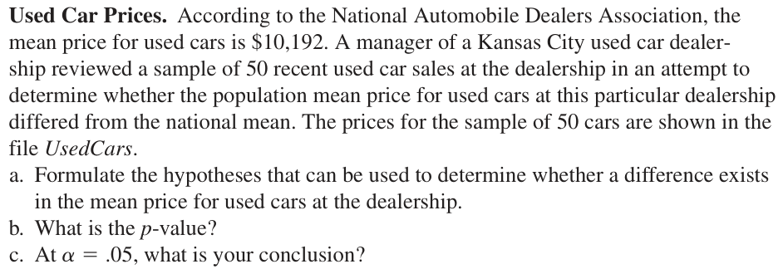  (請直接印出p值或從報表中擷取出p值，而不是只有印出報表。)  (Please directly print the p-value or extract it from the report, rather than just printing the report.)

(2)

(3) | Data file: LateFlights  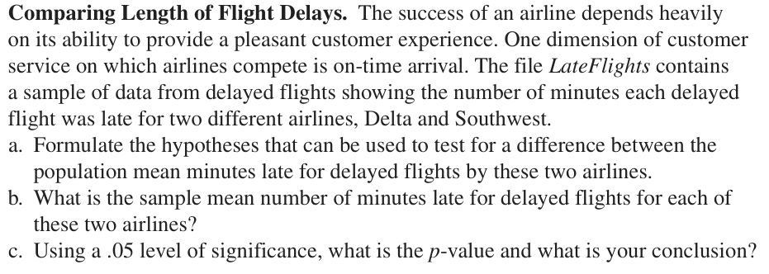  (請直接印出p值或從報表中擷取出p值，而不是只有印出報表。)  (Please directly print the p-value or extract it from the report, rather than just printing the report.)

(4)

(5) | Data file: Bags  